**DAY5 LAB**

**1.Write a program that implement Queue (its operations) using Arrays.**

#include <stdio.h>

#include <stdlib.h>

#define MAX_SIZE 100

int queue[MAX_SIZE];

int front = -1, rear = -1;

void enqueue(int value) {

if (rear == MAX_SIZE - 1) {

printf("Queue is full. Cannot enqueue element.\n");

} else {

if (front == -1) {

front = 0;

}

rear++;

queue[rear] = value;

printf("%d enqueued to the queue.\n", value);

}

}

void dequeue() {

if (front == -1) {

printf("Queue is empty. Cannot dequeue element.\n");

} else {

printf("%d dequeued from the queue.\n", queue[front]);

if (front == rear) {

front = rear = -1;

} else {

front++;

}

}

}

void display() {

if (front == -1) {

printf("Queue is empty.\n");

} else {

printf("Queue elements are: ");

for (int i = front; i <= rear; i++) {

printf("%d ", queue[i]);

}

printf("\n");

}

}

int main() {

enqueue(10);

enqueue(20);

enqueue(30);

display();

dequeue();

dequeue();

display();

return 0;

}

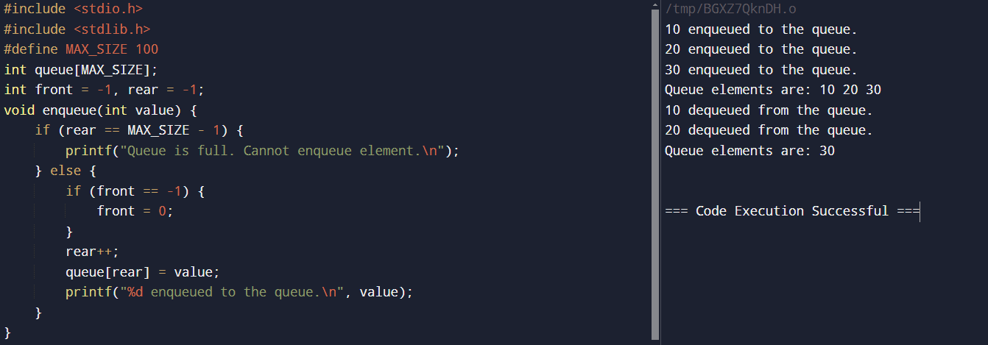

**2.Write a program that implement Queue (its operations) using Linked list(Pointers).**

#include <stdio.h>

#include <stdlib.h>

struct Node {

int data;

struct Node* next;

};

struct Queue {

struct Node *front, *rear;

};

struct Node* newNode(int data) {

struct Node* temp = (struct Node*)malloc(sizeof(struct Node));

temp->data = data;

temp->next = NULL;

return temp;

}

struct Queue* createQueue() {

struct Queue* queue = (struct Queue*)malloc(sizeof(struct Queue));

queue->front = queue->rear = NULL;

return queue;

}

void enqueue(struct Queue* queue, int data) {

struct Node* temp = newNode(data);

if (queue->rear == NULL) {

queue->front = queue->rear = temp;

return;

}

queue->rear->next = temp;

queue->rear = temp;

}

void dequeue(struct Queue* queue) {

if (queue->front == NULL)

return;

struct Node* temp = queue->front;

queue->front = queue->front->next;

if (queue->front == NULL)

queue->rear = NULL;

free(temp);

}

int main() {

struct Queue* queue = createQueue();

enqueue(queue, 10);

enqueue(queue, 20);

enqueue(queue, 30);

dequeue(queue);

printf("Queue Front: %d\n", queue->front->data);

printf("Queue Rear: %d\n", queue->rear->data);

return 0;

}

